**FC IT PRACTICAL FILE**

**ASSIGNMENT 22**

**Q22. Apply Goal seek, Scenario Manager and solver for calculation outcome of interest amount for given principal amount, rate of interest and duration.**

Ans.

Steps:

1. Click on cell where you want to apply goal seek and the at data tab click on what if analysis

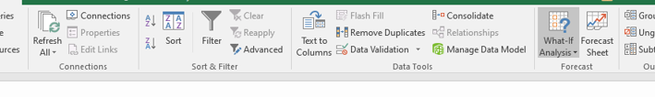

1. Click on goal seek option to apply goal seek then set the goal value you want achieve ,for this select the data which you want change to achieve the goal.

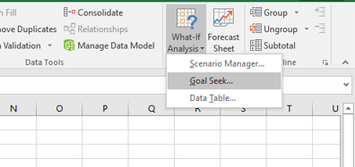

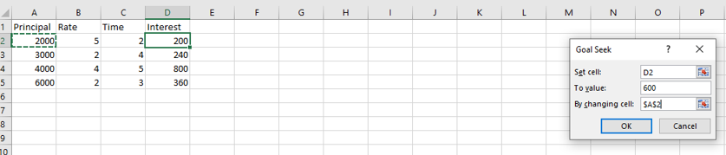

1. Then a dialog box will appears that will tell about data you set is achieved.

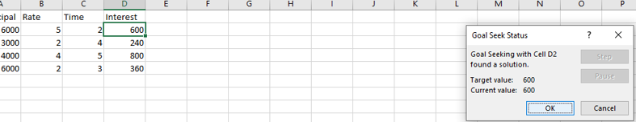

1. For making data table for interest on basis of rate, input different rate and then one select interest value of cell =D2.

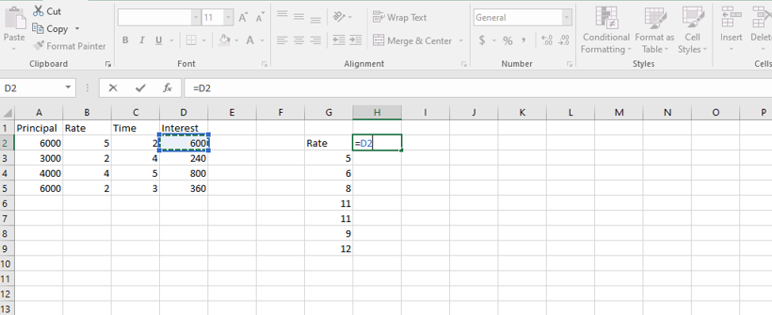

1. Now select the range in which you want to appy data table then click on on data table at what if analysis

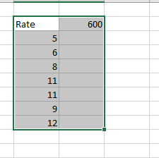

1. Now select the column input cell by clicking the rate value

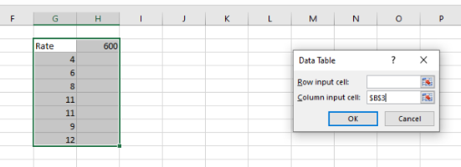

Outcome:

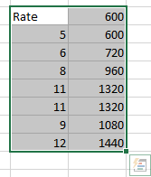

1. Select the range of cell that you want apply scenerio manager,and select scenerio manager option

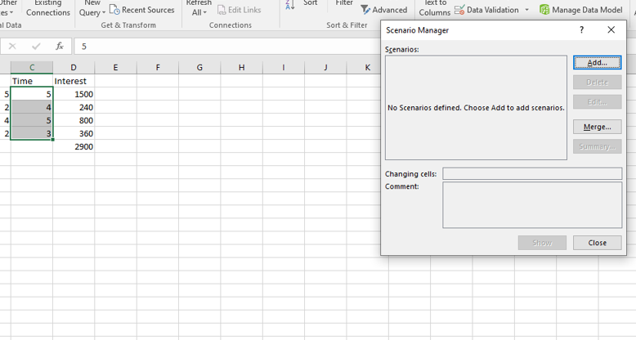

1. Click on add then name the scenerio and then change the value if you want then click on ok.

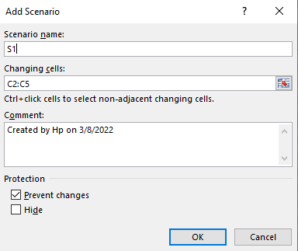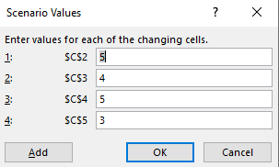

1. Now click on scenerio name that you created and click on show then it will display the previous value of screen.

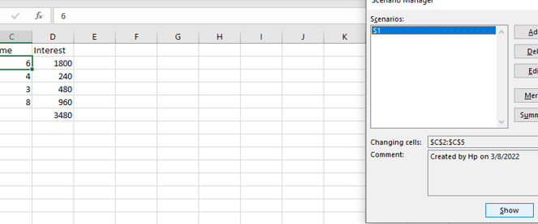

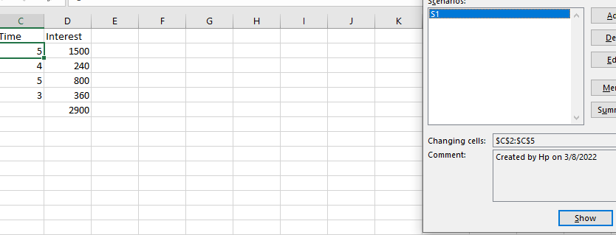

**FC IT PRACTICAL FILE**

**ASSIGNMENT 23**

**Q23 Based upon question number 19, create linked sheet to gather the data of different grades on different sheets.**

**Ans.** Steps:

1. Create 4 new sheets
2. At view tab click on new window a new window will appear.

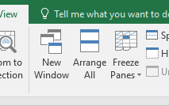

1. Click on arrange all then select the titled and window of active work book and click ok.

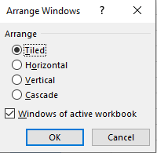

1. Two window are displayed on same screen.

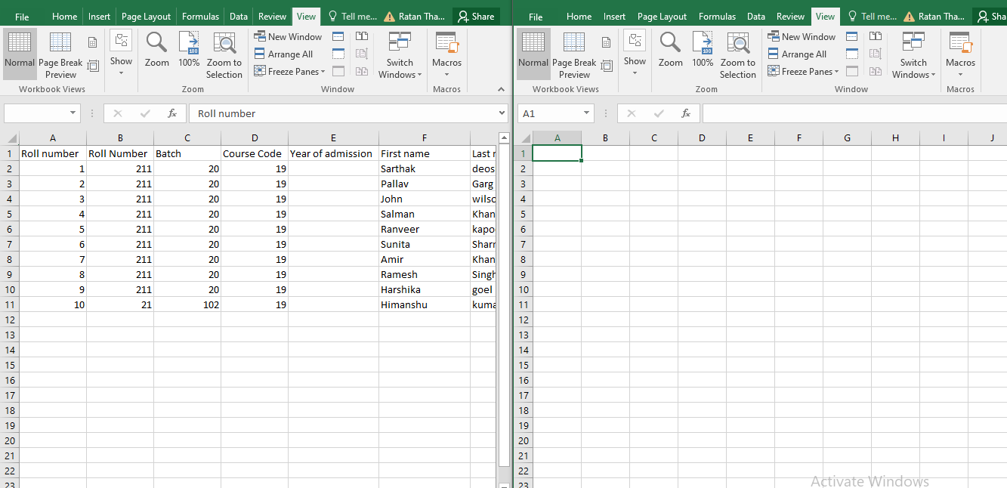

1. Now copy the data of grade from sheet 1 then at sheet 2 select the range and click on paste special a dialog box appears.

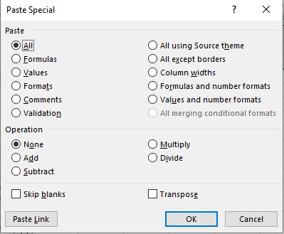

1. Click on paste link your new sheet is linked to previous sheet.

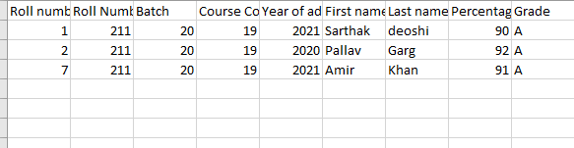

1. Similarly do this with other sheets

Output:

